**Methodology**

The proposed project site is located in Taxila, Rawalpindi Division. The geographical coordinates of Rawalpindi are 33.6°N 73.05°E. The area has a humid subtropical climate with hot and humid summers and cool winters[1]. Mean average annual temperature of Rawalpindi is 21.3 °C (70 °F) and the Average annual rainfall is 1,249 millimeter (49.2 in). Most of the rainfall occurs in the months of July, August and early September in monsoon.

[2]

The project site is selected within University of Engineering and Technology, Taxila. The rooftop of Ibn e Sina block is selected for Rainwater Harvesting as watershed. The rain water will be collected from the selected section of rooftop with the help of a conduit and transported to a flash flood tank. Once this tank is filled, the water will be transported to a retention tank where the suspended particles settle down and finally the water will be stored in a tank.

When the rainfall starts, it carries the contaminants from the atmosphere. This water from initial rainfall is utilized in washing the rooftop and is collected in a flash flood tank.

The stepwise methodology of project is shown in the flowchart below.

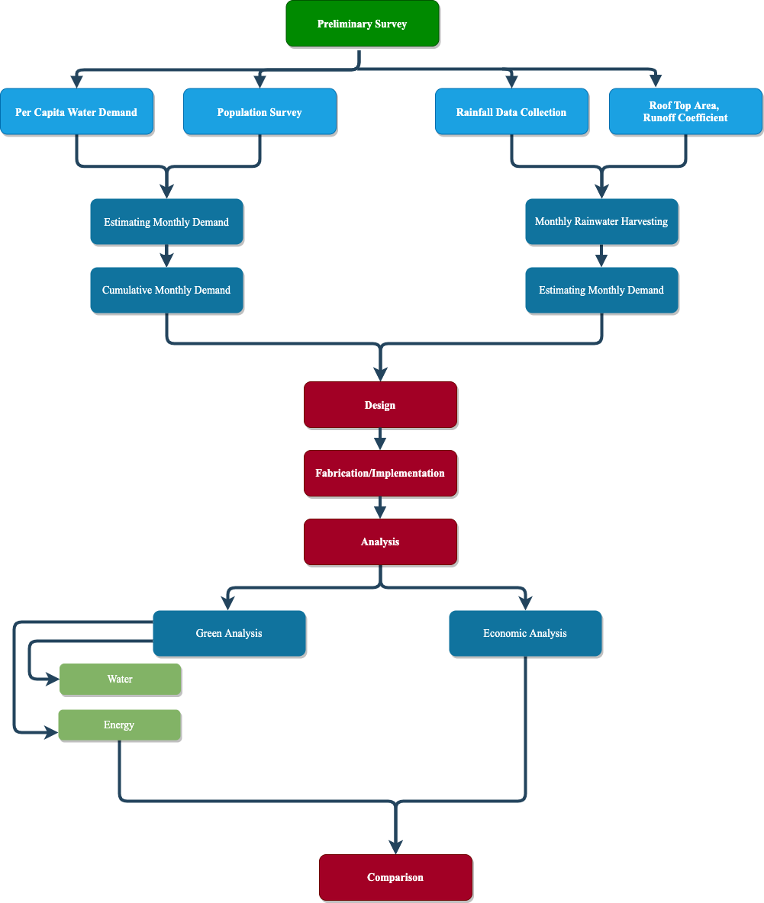

The preliminary site survey is conducted and the details of site are collected which are given below.

**LAB ANALYSIS**

It is very important to check different water quality parameters in order to apply proper treatment before using the stored water. In rain water, important parameters to be consider while treatment include pH, turbidity, total hardness, total suspended and dissolved solids, chloride concentration and bacterial contamination (Mendez, Klenzendorf et al. 2011). These parameters will be checked in the laboratory and the treatment will be done according to the intended use.

|  |  |
| --- | --- |
| PARAMETER | UNIT |
| pH | - |
| Turbidity | N.T.U |
| BOD5 | mg/L |
| Total Suspended Solids | mg/L |
| E. Coli | CFU/100mL |
| Lead | mg/L |

# TREATMENT OF HARVESTED RAIN WATER

Pollution, animal excrement and other particles which are harmful to human beings, plants and animals may be present in Rainwater. Therefore, before utilizing it for various purposes its treatment is necessary. The two primary steps for rainwater treatment includes:

1. **Filtration**
2. **Sterilization (using chlorine or UV light)**

**FILTRATION**

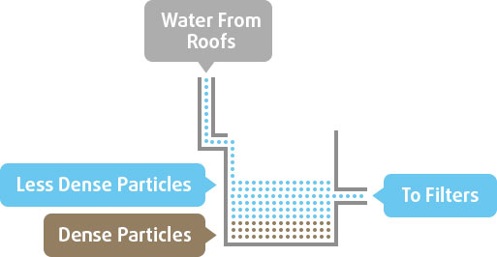

**Figure 6 Filtration**

Removing sediments and small particles from rainwater is the first step of treatment.

The harvested Rainwater from the roofs travel down and get stored in a pit or storage tanks. The sediments which have greater density settle down at the bottom of the tank. The float switch is used to commence a pressure drop inline indicates that the water is needed to treat and transfer immediately. The step of filtration removes 1–5-micron solids using a cartridge, screen or sand filter prior to sterilization. Filters have the option to be self-cleaning.

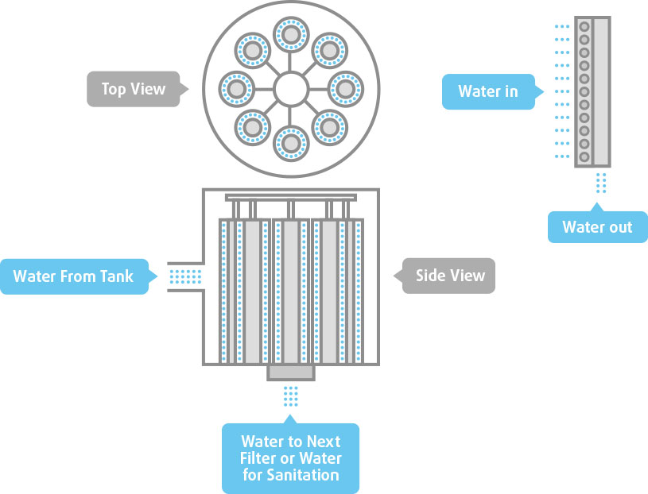

**Figure 7 Top and side view**

**CHLORINE STERILIZATION**

The simple and effective way to sterilize the filter water in adding chlorine.

According to the Victorian Government Department of Human Services:

* The first dosage should be a minimum of 5 milligrams of chlorine per liter of rainwater to be treated
* Maintain a chlorine concentration of 0.5 milligrams per 1 liter of rainwater 30 minutes after the initial treatment.

As a consequence, sterilizing a 50L rainwater tank requires 250mg of chlorine. Following the initial treatment, the chlorine content must be maintained at 25 mg per liter for 30 minutes.

**Advantages of Chlorine Sterilization**

* It is an ideal solution for harvested rainwater, the purpose of which is to be utilized for various functions.
* It ensures the compliance of rainwater with regulations all the time, as the sampling pump will automatically regulate the appropriate chlorine concentration.

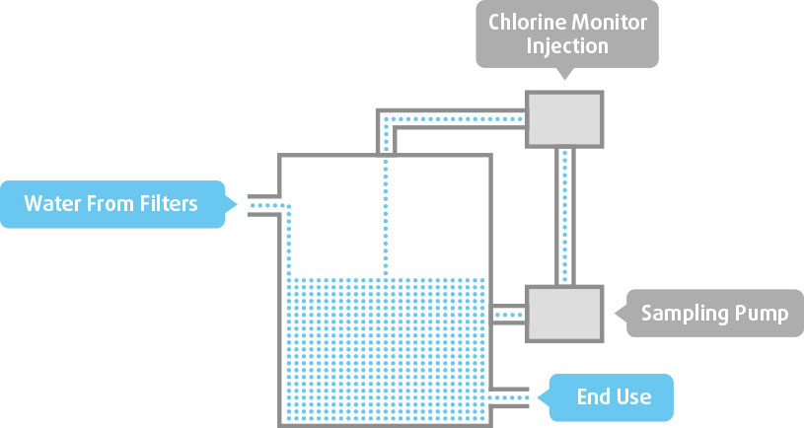

**Figure 8 Chlorine injection**

**ULTRAVIOLET STERILIZATION**

UV light serves as an alternative of sterilization. The working principle of Ultraviolet light is to disrupt and damage the pathogenic cells.

It requires the harvested rainwater to be free of any large sediments or particles before sterilization. The phenomena of shadowing can occur if rainwater is not filtered, which ultimately block the UV light rays and reduces the effectiveness of sterilization process.

**Advantages of UV Sterilization**

* UV light bulbs have a lifespan of 12 to 2 years.
* UV systems can sustain high flow rates.
* Water that has been treated with UV light can be utilized right away.
* Rainwater that has been UV-treated is less likely to corrode metal that has been exposed.

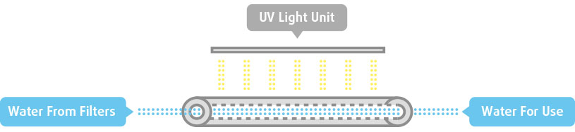

# ROOFING MATERIAL COMPARISON

The effect of roofing material on rainwater harvesting quality will be studied by comparing the roof surfaces. The roof surfaces to be compared will comprise of:

|  |  |
| --- | --- |
| Sr. no | Roof Surface |
|  | Asphalt |
|  | Metal |
|  | Concrete Tile |
|  | Green Roofs |

Convectional roofing materials which include Asphalt, Metal and concrete tile along with the alternative roofing material consisting of green roofs will be used for harvesting rainwater, the water will be subjected to examination where following parameters will be checked. (Mendez, Klenzendorf et al. 2011)

|  |  |
| --- | --- |
| Sr. no | Parameters |
|  | pH |
|  | Conductivity |
|  | TC and FC |
|  | Turbidity |
|  | TSS |
|  | Nitrite and Nitrate |
|  | DOC |
|  | Metals |
|  | VOCs |
|  | SVOCs |

The comparison will be done on the basis of parameters values obtained for each roofing material.

**INTENDED USES**

The intended uses of harvested rainwater are mentioned below

* Washing of buses
* Laundry
* Road washing
* Horticulture
* Mosque

**REFERENCES**

Mendez, C. B., et al. (2011). "The effect of roofing material on the quality of harvested rainwater." water research **45**(5): 2049-2059.

1. [Climate | Rawalpindi (punjab.gov.pk)](https://rawalpindi.punjab.gov.pk/climate)
2. [Rawalpindi, Pakistan - Detailed climate information and monthly weather forecast | Weather Atlas (weather-atlas.com)](https://www.weather-atlas.com/en/pakistan/rawalpindi-climate#rainfall)